Linked List

1. Inserting Node at the End

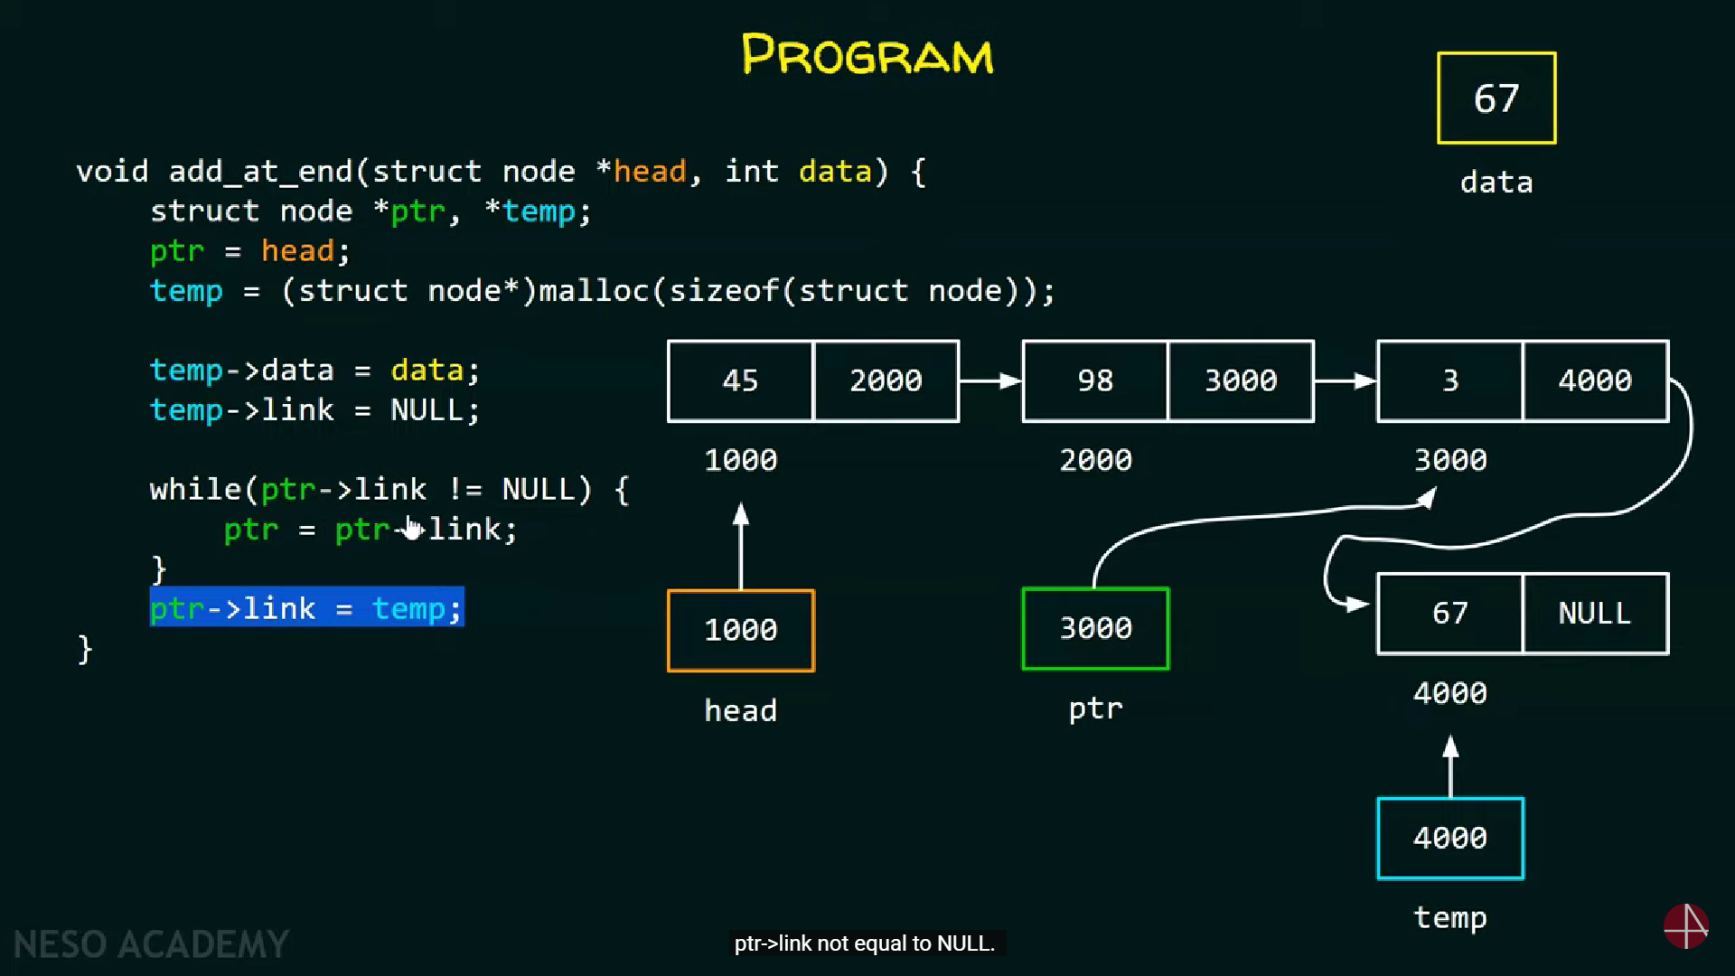

1. Inserting Node at the Beginning

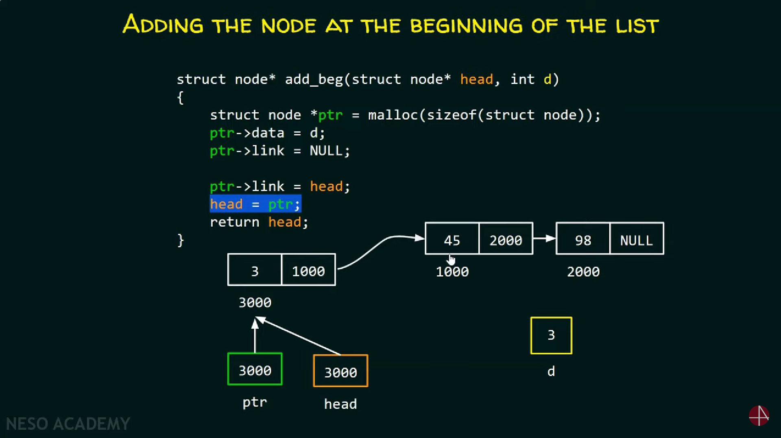

1. Inserting Node at a Certain Position

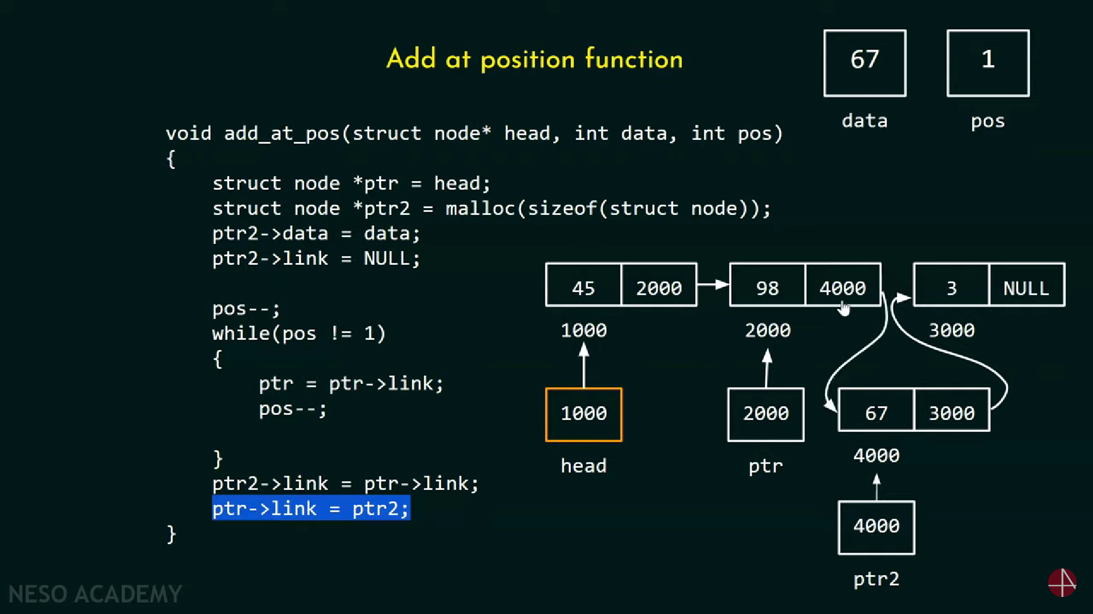

1. Deleting the First Node

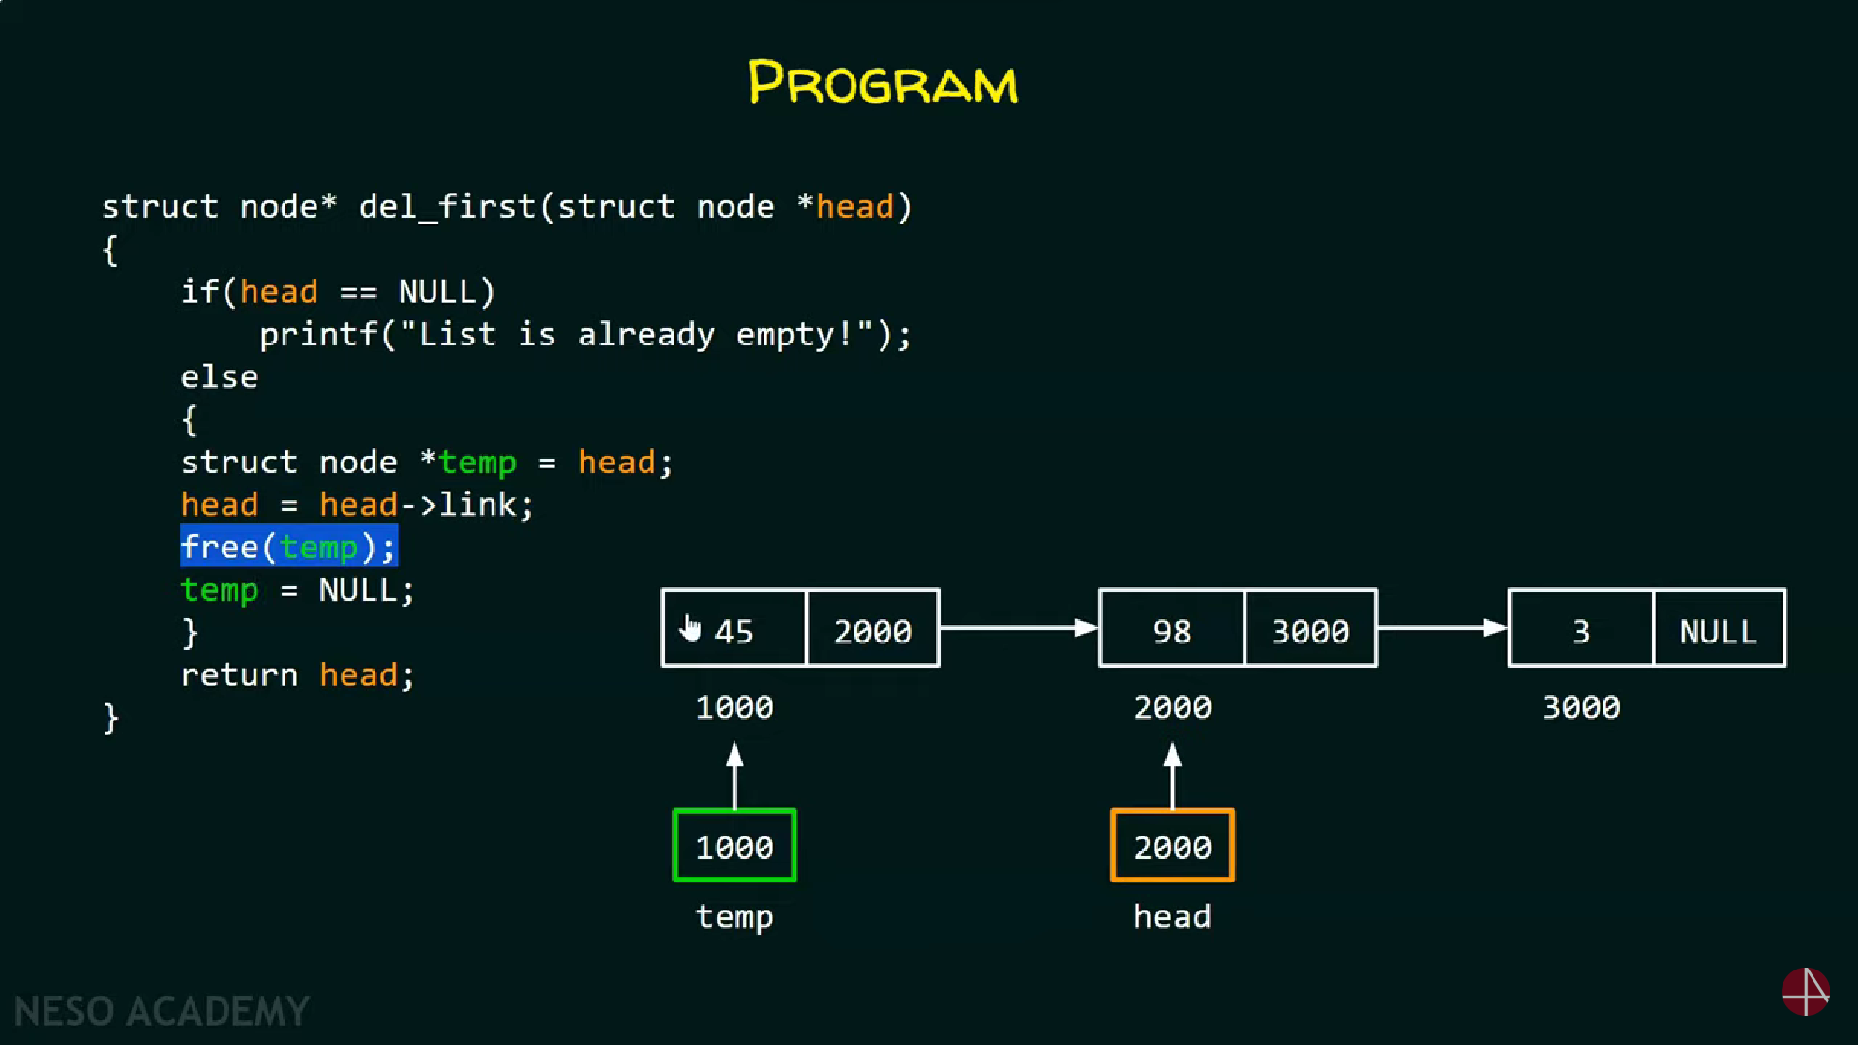

1. Deleting the Last Node

